Easyton advantages compared to Diaton
Transpalpebral tonometry is known as a method of IOP measurement for more than 15 years. At the very beginning, when the first Diaton tonometer was made, there was a team of engineers who worked on its creation. After a while, the team split up and several engineers continued their work at ELAMED. 10 years of development, trials and improvement resulted in new tonometer concept – EASYTON. Since the process of EASYTON development, did not stop, unlike Diaton, the tonometer has many advantages compared to its competitor:
- Measurement method:
EASYTON measures IOP through vibration. There are about 100 vibration per 1 second (1 vibration is one measurement), about 80% vibration are done to compensate eyelid thickness d 20% are done to calculate the most accurate IOP value.
Diaton, on the other hand, does not use vibration; it measures IOP by dropping some load on the eyelid, as a result additional methodological errors of the method appear. Moreover, this measurement method does not take into account the thickness of the eyelid and does not compensate it.
- Way of measurement making:
EASYTON measuring rod is designed to simplify the measurement process as much as possible and has simple visual design.
Diaton measuring rod has additional supports in the form of two protrusions, but it can hardly be attributed as advantage of the device. This appliance cannot actually immobilize the eyelid and does not take into account the anatomy of the eye. Still it can cause complications for the measurement procedure by making it difficult to see the measuring rod and to position it on the eye correctly.
- Calculation method:
As mentioned above, EASYTON actually makes 100 measurements at one touch of the eyelid, and the average most accurate value is displayed.
Diaton makes only 1 measurement at 1 touch. After each measurement it is necessary to return the rod to start position, which increases the time of screening.
- Medical trials:
The accuracy and repeatability of Easyton is confirmed by Goldmann comparison trial and Cadaver Eye Testing. Moreover, a lot of doctors using Easyton underline the repeatability of our device.
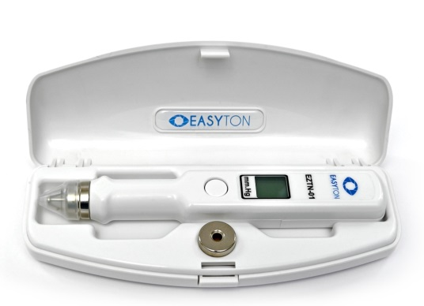
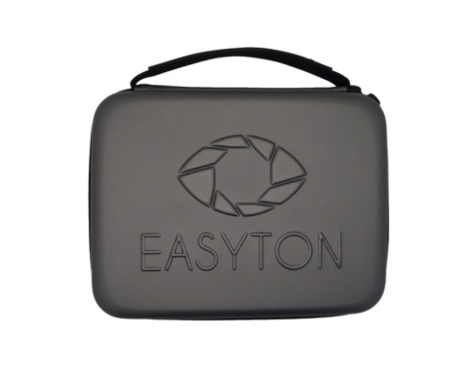
Diaton has only Goldmann comparison trial

